**Response Curve**

**Fundamental Concept of RC :** Law Diminishing marginal returns (Explanation by example)

* As you keep adding variable resources to a fixed resource the additional output will eventually decrease, which simply is called as law of Diminishing marginal return.

*Example: -*

*If you owned a pizza outlet, how would you determine the optimum number of workers needed at your pizza joint?*

*What happened when you hire more and more workers what happens to numbers of pizza they can produce.*

*Below is an example which illustrates the diminishing margin*

|  |  |  |
| --- | --- | --- |
| **# of Workers** | **# of Pizza** | **Marginal Product** |
| 0 | 0 | 0 |
| 1 | 5 | 5 |
| 2 | 15 | 10 |
| 3 | 20 | 5 |
| 4 | 22 | 2 |
| 5 | 22 | 0 |
| 6 | 18 | -4 |

1. If you notice the Marginal product (*Which is additional Pizza when added new worker*) is decreasing over time when you keep adding new additional resources to the pizza outlet
2. 1 worker produces 5 pizza, While 2 workers are able to produce 15 pizza which is 10 additional pizza this is called the *Benefit of specialization.* But when you hire 3rd worker the additional output has decreased

Since we have understood the concept in a Layman’s-term, let’s understand different stages of diminishing margin –

**Stages – (As highlighted in below chart)**

Stage 1 – Total product increasing with increase in marginal product

Stage 2 – Total product increasing with a decreasing rate but marginal product is decreasing

Stage 3 – Total Product in decreasing with decreasing rate of marginal product

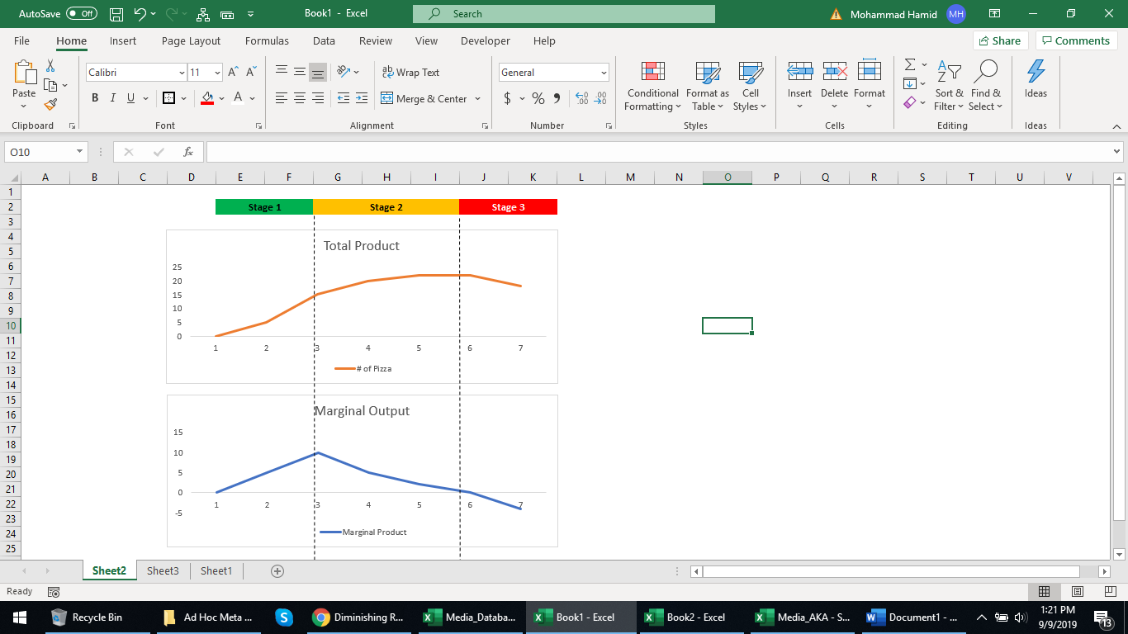

Our response curve/Power curve/S-Curve is based on this law only, it’s just we use different function to achieve it based on different product-client case scenarios.

So if you relate it to your GRPs it is basically the same concept, It’s response per GRP gets decreased over time when you keep airing your TV GRPs.

**Gamma Transformation –**

We use this transformation to convert the GRPs in order to test it into the model, It is majorly followed for all study.

Below are parameters used for this transformation –

* Degrees of Freedom (DOF)
* Decay Rate
* No: of Weeks

DOF – Controls how early your Minimum threshold point should be reached... Lower the DOF, higher the impact of GRPs in the initial phase of execution.

When DOF is set to 1, the chart looks as below.

Decay Rate – % of people forgetting about the advertisement in the next week after the execution is done. It is opposite of retention rate which basically tells how many people tend to retain the ad in the next week. The lower the decay the longer it will spread across following weeks. Standard range varies between 1% to 100%

No: Of Weeks: Number of weeks after which people would completely forget your advertisement

**Response curve & profit curve**

**Response curve** is a mechanism identifying how your Response (Incr. Volume Per GRP) moves along with additional GRPs. It helps you explain what the optimal level of GRPs is to attain the maximum volume response and what is your saturation point.

**Profit curve** is basically a conversion of Response curves into profit curve by simply multiplying the volume with **Marginal Price** and reducing the expenses of GRPs

A standard output of response curve (Using the input based on Gamma Transformation) looks like below –

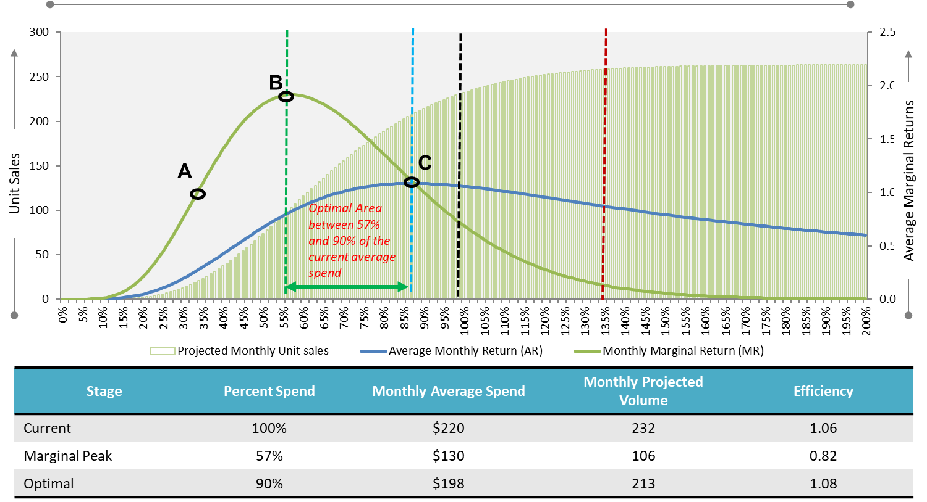

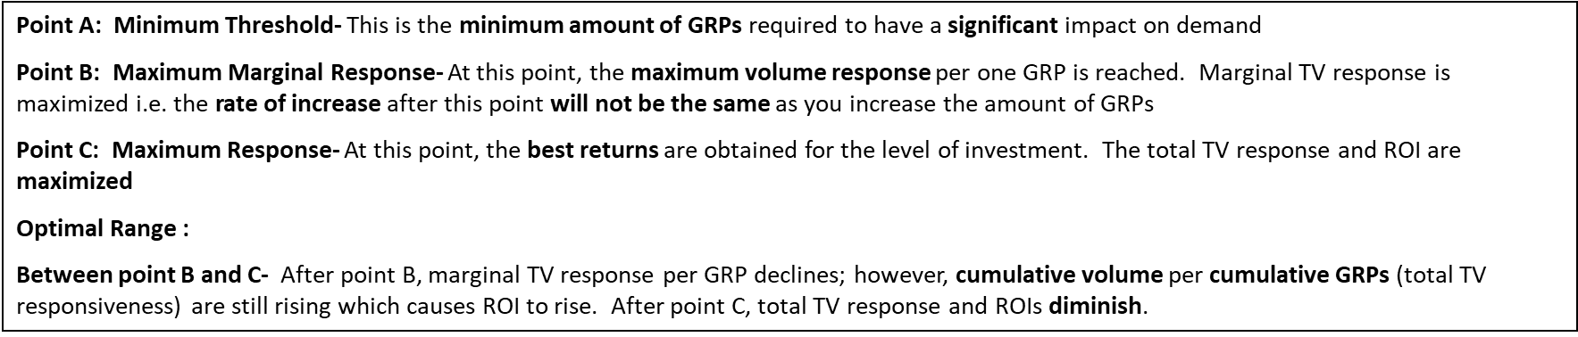

**How to work with the Excel Gamma Tool :**

**Step 1:** Update the Weeks

**Step 2:** Update the Raw GRPs

**Step 3:** Update the Saturation Parameters

**Step 4:** Paste the Incremental Volume (Decomp) from the model

**Step 5: Copy paste the Alpha & Beta parameters from red cell to 1 cell left**

**Setp 6: Adjust the coefficient to get the volume equal to model decomp**

**Step 7: Press the button “Generate Volume”**

**End**

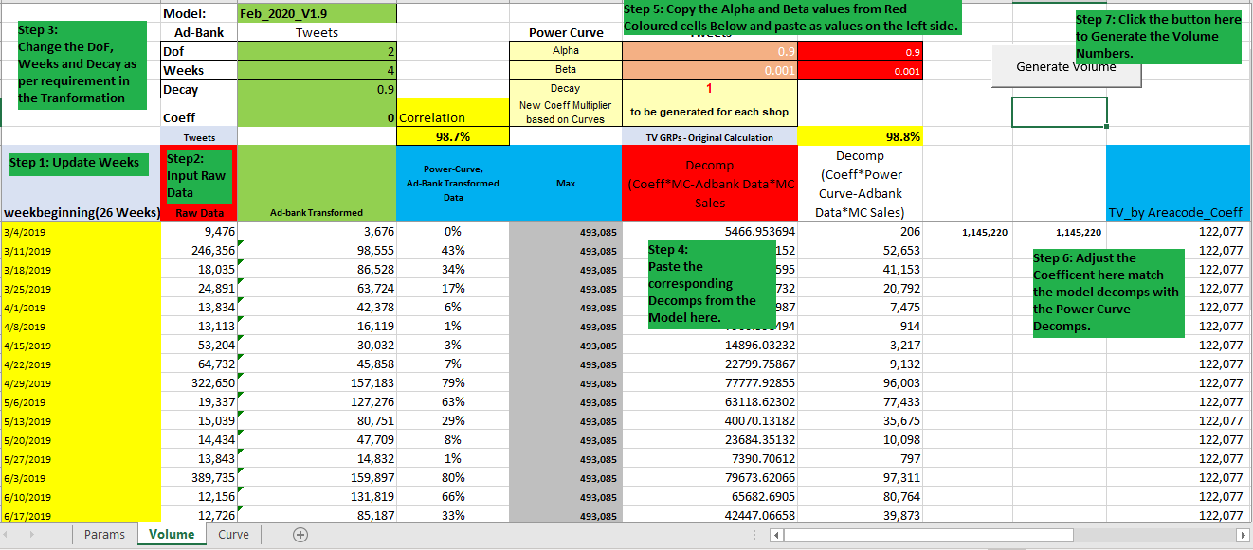

**Validation:**

1. Decomp from the tool should match with the actual incremental decomp.
2. Adjust the coefficient if total decomp is not matching
3. Correlation should be close to 100% between actual decomp vs. tool generated decomp

**Delta Transformation –**

We use this transformation to convert the GRPs in order to test it into the model, It is majorly followed for all Coke MVA study.

Below are parameters used for this transformation –

* R Parameters
* Decay Rate

R Parameters – This parameter used to control the saturation level. The lesser the R value the early it will get saturate. The Higher the R value it will take more GRPs to saturation. It ranges between 0.10 to 0.99

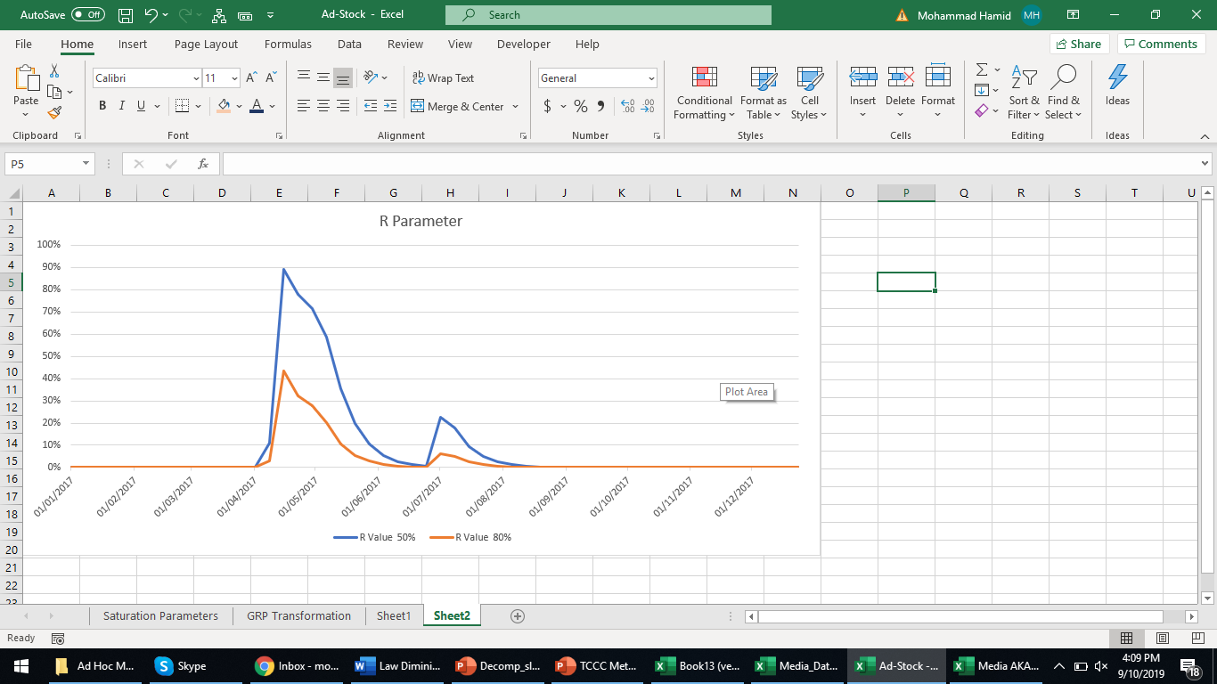

Decay Rate – % of people forgetting about the advertisement in the next week after the execution is done. It is opposite of retention rate which basically tells how many people tend to retain the ad in the next week. The lower the decay the longer it will spread across following weeks. Standard range varies between 1% to 100%

**Response curve & profit curve**

**Response curve** is a mechanism identifying how your Response (Incr. Volume Per GRP) moves along with additional GRPs. It helps you explain what is the optimal level of GRPs to attain the maximum volume response and what is your saturation point.

**Profit curve** is basically a conversion of Response curves into profit curve by simply multiplying the volume with **Marginal Price** and reducing the expenses of GRPs

A standard output of response curve (Using the input based on Delta Transformation) looks like below –

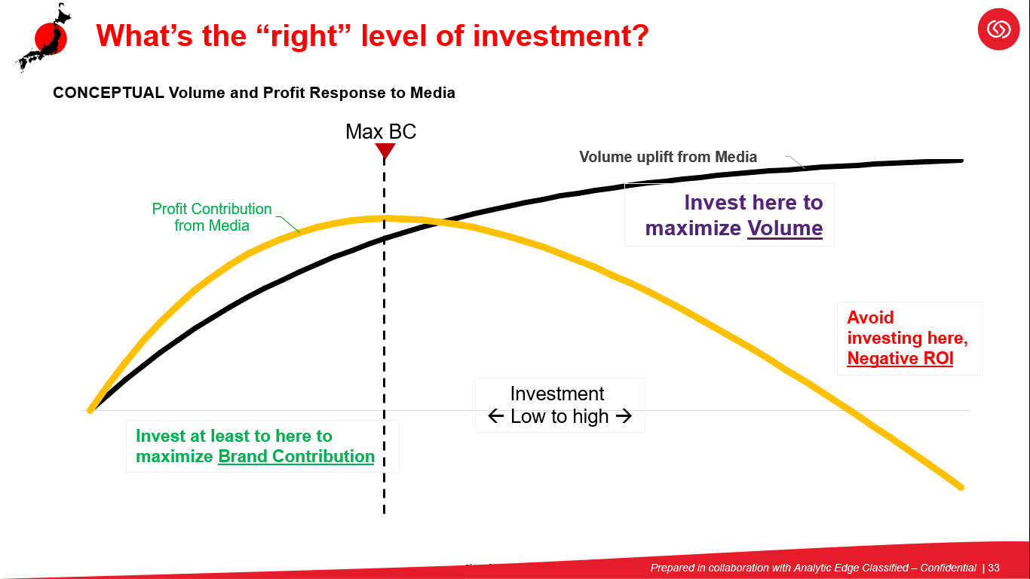

**Coke Specific Tool for Response curve and Profit curve**

|  |  |  |  |  |  |
| --- | --- | --- | --- | --- | --- |
| **Brand Name** | **ST** | **LT** | **Total** |  | **Manual Input** |
| Coef | 0.053 | 0.050 | 0.103 |  | Average coefficient |
| Coef adj | 1.39722 |  |  |  | To Match the Total Volume |
| Spend | 3,690,580,000 |  |  |  | Yearly Expenditure |
| GRPs | 21,949 |  |  |  | Yearly Expenditure |
| Cost/GRP | 168,143 |  |  |  | - |
| 2017 GP/UC | 445 |  |  |  | Yearly GP Per UC |
| 2017 ST incr volume | 6,539,877 |  |  |  | Short Term Volume |
| 2017 LT incr volume | 8,145,357 |  |  |  | Long Term Volume |
| 2017 Total incr volume | 14,685,234 |  |  |  | - |
| 2017 Sales UC | **179,451,510** |  |  |  | Dependent (Yearly) |
| ST Vol uplift at actual GRPs, computed short hand | 6,350,855 |  |  |  | - |
| Vol uplift at actual GRPs, computed short hand | 14,685,234 |  |  |  | - |
| ROI | 1.7709 |  |  |  | - |

* Yellow highlighted cells you need to update
* Your Final Volume “***Vol uplift at actual GRPs, computed short hand”*** should exactly match with Total coming from the primary model
* Check if ROI is matching with the ROI reported from Primary model

**Result Validation**

**Scenario 1** -

* Opportunity to further increase GRPs to achieve **Profit Max**

**Scenario 2** -

* Over execution of GRPs, Needs to cut down the GRPs to **Maximize** **Profit**

**Scenario 3** -

* Media is not profitable. Can be validated with the primary model. Your ROI must not be crossing the profit threshold (ROI < 1)
* It happens when your campaign is not working well, or probably you are dealing with a growing brand which is small in size and hence not getting a good ROI
* In this case you wouldn’t get a **Profit Max** point